Module 1: Introduction to epidemiology and factors influencing disease transmission
Contributors: Scott Wells, Amy Kinsley
In this module, you will explore the following:
- What is epidemiology?
- How is epidemiology useful in clinical veterinary practice?
- What key concepts are involved in an epidemiologic approach to health management?

What is Epidemiology?

Epidemiology can be defined as the study of patterns of occurrence of disease (or health) in animal populations through time. A key concept is consideration of disease (or health) in the population of animals involved, not only in individual animals. Another key concept is that the disease evaluated is typically naturally occurring disease under ‘field conditions’ rather than a laboratory.
From Stevenson’s textbook ‘An Introduction to Veterinary Epidemiology,’ page 6:
‘Epidemiology is the study of diseases in populations. Epidemiologists attempt to characterize those individuals in a population with high levels of disease and those with low levels. They then ask questions that help them discover what the high rate group is doing that the low rate group is not and vice versa. This allows factors influencing the risk of disease to be identified. Once identified, measures can be applied to reduce exposure to these risk factors -- reducing the overall burden of disease in the population. This allows disease to be controlled even if the precise pathogenic mechanism (or the aetiologic agent) is not known.’

How is epidemiology useful in clinical veterinary practice?

So why is epidemiology important for veterinary practitioners? And why therefore is it important for veterinary students to learn how to apply epidemiologic principles to clinical situations?
Understanding the principles of epidemiology can be helpful for decision-making in veterinary clinical practice, for addressing questions such as the following:
- Is this animal sick (different from normal or healthy)?
- How has disease affected an animal population (a herd, flock, kennel, or other)?
- How do I interpret this test result?
- How to know if a certain (risk) factor is associated with a disease?
- How to know if a certain factor causes disease?
- How to interpret information from scientific studies to make decisions?
- How to use these concepts to control or prevent disease?
While epidemiology is population-based, often involving comparisons between different groups of animals, it is also fundamental to veterinary decision-making for individual animals.
From Stevenson’s text, p. 6. There is a link to this on-line Veterinary Epidemiology textbook in entirety on the course homepage. This textbook may be a helpful resource for you throughout the course, as it covers most of the course concepts in a different voice from that used by the course instructors.
‘It is useful to distinguish epidemiological from clinical approaches to disease management.
The clinical approach to disease management is focused on individual animals and is aimed at diagnosing a disease and then treating it. It involves physical examination and generation of a list of differential diagnoses. Further examinations, laboratory tests and possibly response to treatment are then used to narrow the list of differential diagnoses to a single diagnosis. In an ideal world, this will always be the correct diagnosis. Research in health professionals has shown that the final diagnosis is nearly always drawn from the initial list of differential diagnoses. If the disease is not on the initial list of differentials, then it tends not to become the final diagnosis. Diseases may be omitted from the list because the clinician is not familiar with them (exotic or unusual diseases) or because the disease is `new' and has never been identified before.
The epidemiological approach to disease management is conceptually different in that there is no dependency on being able to precisely define the aetiological agent. It is based on observing differences and similarities between diseased and non-diseased animals in order to try and understand what factors may be increasing or reducing the risk of disease. In practice, clinicians unwittingly use a combination of clinical and epidemiological approaches in their day-to-day work. If the problem is relatively clear-cut, then an epidemiological approach plays a very minor role. If the condition is new or more complex, then the epidemiological approach is preferred since it will provide a better understanding of what makes individuals susceptible to disease and - once these factors are known - the measures required to control the disease become better defined.’
In this course, you will not only learn key concepts and principles involved in clinical epidemiology, but will also learn to apply these concepts and principles to inform decision-making, using multiple case study examples. Through this process, you will learn to incorporate epidemiologic principles into your approach to disease management, so rather than segregating clinical from epidemiologic approaches, you instead employ both of these together into a more holistic approach to disease management. The purpose of epidemiology is “to provide data on which a rational decision for the prevention and/or control of disease in animal populations can be based.” (Martin. Meek, and Willeberg, Veterinary Epidemiology Principles and Methods, 1987). Without it, we rely on our experience and impressions which are inevitably biased in unknown countless ways.
The focus of this course is clinical epidemiology, the application of epidemiologic principles to inform veterinary decision-making in clinical practice. Use of epidemiologic methods is also common for other purposes, including many types of population-level research and development. While the objective of this course is not to provide training in research methods, some aspects of epidemiologic principles relative to research and development will be covered to assist you as a veterinarian to use information from scientific literature as part of your decision-making process.

What key concepts are involved in an epidemiologic approach to animal health management?

3a. Factors that determine disease occurrence (The Epidemiologic Triad - host, agent, and environment)

Disease occurrence or absence depends on the involvement of three key factors:
- Host – the animal(s) infected with the disease
- Agent – the pathogen that causes the disease
- Environment – external factors that influence disease occurrence
From Stevenson’s text, pages 6-7:
‘Whether or not disease occurs in an individual depends on an interplay of three factors:
- The host is the animal (or human) that may contract a disease. Age, genetic makeup, level of exposure, and state of health all influence a host's susceptibility to developing disease.
- The agent is the factor that causes the disease (bacteria, virus, parasite, fungus, chemical poison, nutritional deficiency, etc) - one or more agents may be involved.
- The environment includes surroundings and conditions either within the host or external to it, that cause or allow disease transmission to occur. The environment may weaken the host and increase its susceptibility to disease or provide conditions that favour the survival of the agent.’
Since these three factors collectively determine disease occurrence, your goal as an epidemiologist is to disrupt the linkages between these factors to stop (or minimize) the occurrence of disease.
Watch the video titled: Epidemiology Determinants of Disease

3b. Factors that influence the level of disease in an animal population (individual, place, and time)

From Stevenson’s text, pages 7-9:
‘The level of disease in a population depends on an interplay of three factors:
- Individual factors: What types of individuals tend to develop disease and who tends to be spared?
- Spatial factors: Where is the disease especially common or rare, and what is different about these places?
- Temporal factors: How does disease frequency change over time, and what other factors are associated with these changes?

Individual factors
Individuals can be grouped or distinguished on a number of characteristics: age, sex, breed, coat colour and so on. An important component of epidemiological research is aimed at determining the influence of individual characteristics on the risk of disease. Figure 1 shows how mortality rate for drowning varied among children and young adults in the USA during 1999. The rate was highest in those aged 1 to 4 years: an age when children are mobile and curious about everything around them, even though they do not understand the hazards of deep water or how to survive if they fall in. What conclusions do we draw from this? Mortality as a result of drowning is highest in children aged 1 to 4 years: preventive measures should be targeted at this age group.
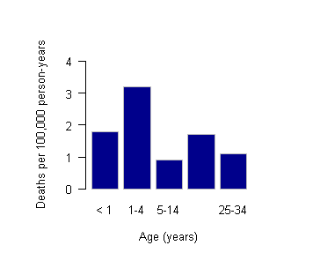
Figure 1: Mortality from drowning by age: USA, 1999. Reproduced from: Hoyert DL, Arias E, Smith BL, Murphy SL, Kochanek KD (2001) Deaths: final data for 1999. National Vital Statistics Reports volume 49, number 8. Hyattsville MD: National Center for Health Statistics.

Place (Spatial factors)
The spatial pattern of disease is typically a consequence of environmental factors. Environmental factors include aspects of climate (temperature, humidity, rainfall) as well as aspects of animal management (management of animals in a certain area of a country may result in high rates of disease that may not be seen in other areas). Geographic Information Systems and easy access to spatial data (e.g. satellite images) have facilitated the ability to conduct spatial epidemiological analyses in recent years. Figure 2 shows the geographical distribution of BSE incidence risk in British cattle from July 1992 to June 1993. The amount and type of concentrate feeds fed to cattle is thought to have been responsible for the higher density of disease in the south of the country, compared with the north.

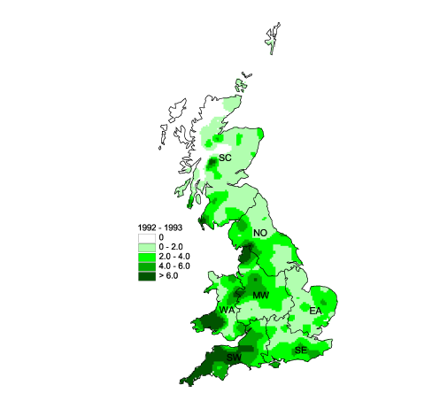

Figure 2: Incidence risk of BSE across Great Britain (expressed as confirmed BSE cases per 100 adult cattle per square kilometre), July 1992 { June 1993. Reproduced from Stevenson et al. (2000)

Time (temporal factors)
When talking about temporal factors influencing the pattern of disease we need to distinguish between animal referent time and calendar time. Animal referent time refers to the timing of events in relation to defined events that occur during an animal’s lifetime.
For example, we may talk of an increased risk of milk fever during the first 7 days of a lactation. Here, time is measured in relation to a calving event. Calendar time refers to the absolute timing of events. We may talk of the number of milk fever cases that occur in August, and compare those numbers with the number that occur in (say) December.
Temporal patterns of disease in populations are presented graphically using epidemic curves. An epidemic curve consists of a bar chart showing time on the horizontal axis and the number of new cases on the vertical axis, as shown in Figure 3.
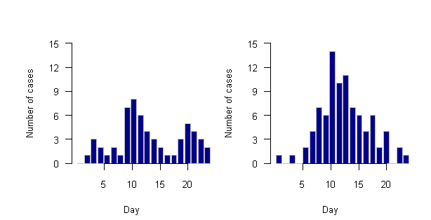
Figure 3: Epidemic curves. The plot on the left is typical of a propagated epidemic. The curve on the right is typical of a common source epidemic.
The shape of an epidemic curve can provide important information about the nature of the disease under investigation. An epidemic occurs when there is a rapid increase in the level of disease in a population. An epidemic is usually heralded by an exponential rise in the number of cases in time and a subsequent decline as susceptible animals are exhausted. Epidemics may arise from the introduction of a novel pathogen (or strain) to a previously unexposed (naive) population or as a result of the re-growth of susceptible numbers some time after a previous epidemic due to the same infectious agent.’
We will learn more about epidemic curves in Module 2 of this course.

3c. Infectious disease epidemiology concepts

Realizing that disease occurrence depends on the epidemiologic triad (agent, host, and environment), now is a good opportunity to review key principles of infectious disease epidemiology.
Infectious diseases are diseases caused by pathogenic microorganisms (bacteria, viruses, parasites or fungi) and can be transmitted, directly or indirectly, from one individual to another (WHO). From the Agents of Disease courses, you have already learned a great deal about infectious agents, including:
- Characteristics of infectious agents and their ‘strategies’ for survival
- Transmission of infectious agents
- Roles of different types of hosts: primary maintenance host, secondary host, amplifier host, and incidental hosts.
- Transmission of infectious diseases occurs when a pathogen is transmitted between hosts. In order for infectious diseases to spread, certain conditions must be met:
- A microbial agent must be present
- A reservoir for the agent is maintained
- An agent exits the reservoir through portal(s)
- A path of entry of the agent into a new host
- The agent is able to invade the new host
- The host (animal) must be susceptible to infection
Some key infectious disease epidemiology concepts:
- The risk of disease to individuals is influenced by the infectious status of others.
- Contact patterns play a major role in diseases transmitted through direct contacts or close indirect contacts with others.
- Subclinical infections influence the epidemiology of disease, with the following examples (in humans):
  - Carriers – ‘Typhoid Mary’ for Salmonella
  - ’Superspreader’ – Severe acute respiratory syndrome (SARS in Asia in 2003-2004) and COVID-19

Case 1.1: Infectious disease transmission
- Review the information on Disease Transmission Methods.
Please note: The Check your Understanding section of this article is an optional task and is not an assignment.
- Next, go to the ISU Center for Food Security and Public Health Disease webpage. This is a very useful resource for future use.
- Using the CFSPH Main Menu navigation, click on Infection Control and navigate to Disease Exposure Routes
- Review transmission modes of several important animal pathogens
- Under Specific Diseases by Exposure Route, select an animal species, identify a disease and identify the modes of transmission.

For the disease you identified, outline on a flow diagram:
- Infectious agent
- Potential routes of transmission
Next, check to see if the disease you selected can be found on this website, either by clicking on:
- Animal Disease Information (left side of page), then click on Animal Disease List, OR
- Zoonotic Diseases (left side of page), then click on Specific Zoonotic Diseases.
- If the disease you selected is on either of these lists, you can find additional information to add more details to your flow diagram by clicking on ‘Technical Fact Sheet’, and reviewing the section titled 'Transmission.'
  - Potential portals of agent exit from an infected animal
  - Potential portals of agent entry into a susceptible animal
  - Reservoirs where the agent maintains itself
  - Factors associated with disease occurrence

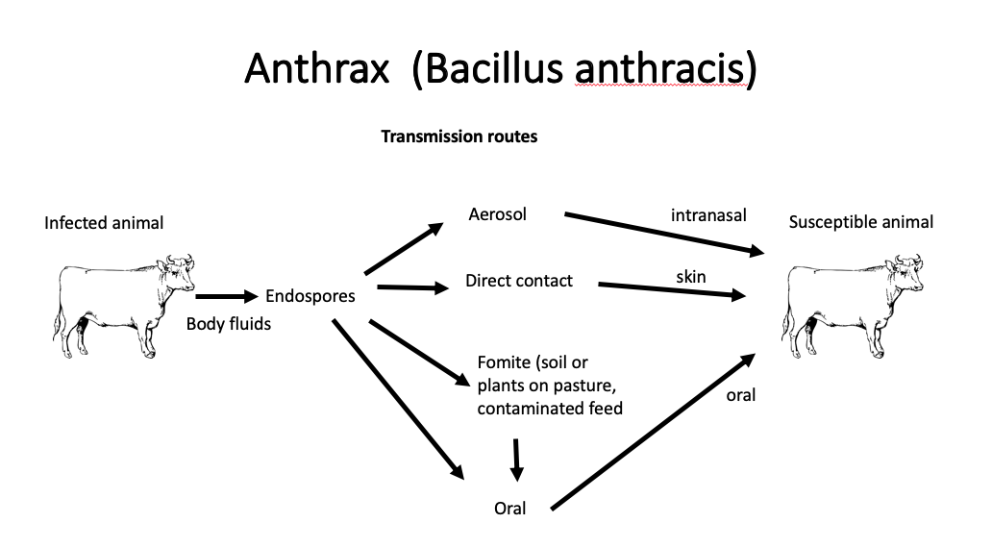
Case 1.2. An example of disease transmission

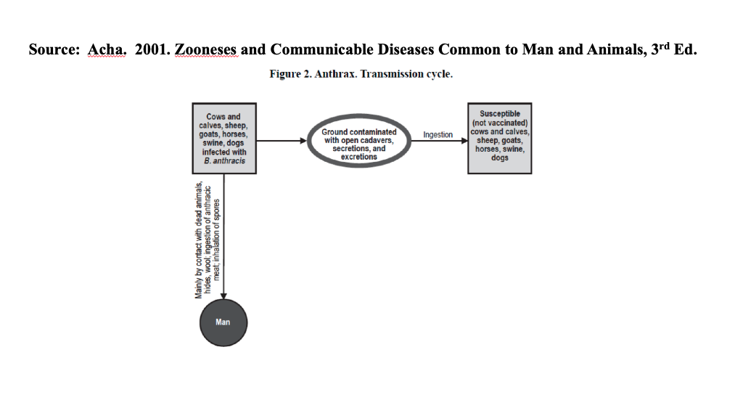

Case 1.3. Epidemiology in clinical practice

The following case is an example case of situations faced repeatedly in clinical veterinary practice across the board, from small animal practice or other types. Note: Why it is important to consider more information than solely the individual animal involved when treating and managing health in animals?
Your knowledge of veterinary medicine will provide you with a general plan of diagnosis and treatment, but this plan often needs to be adapted to fit the specific situation, based on other information, including the epidemiology of disease. Understanding of the agent-host-environment epidemiologic triad is one important consideration that will be very useful for decision-making in clinical veterinary practice and will allow you to be a more effective clinician in practice.
You are presented with a 12 week old puppy with diarrhea. The puppy was obtained 2 weeks ago and appeared to be normal and healthy, but now shows bloody diarrhea and weight loss as well as pale gums. Following a fecal float exam which detected hookworms, you provide anthelmintic treatment and send the dog home.
Four weeks later, the same client calls again. The puppy is showing similar signs, and the client asks if you can repeat the treatment. She also asks why your treatment did not work the first time to cure the problem.
Jot down your responses to the following questions:
- How would you respond to your client in this case?
- What additional information would be helpful in responding to this case?
- Provide information showing agent, host, and environmental factors that could be important in determining the presence of disease in the puppy?

After you have your answers, compare your answers to those written below:
In epidemiology, we consider the epidemiologic triad of factors important in determining the presence of disease in individuals.
- How would you respond to your client in this case?
You initially thank your client for being an observant owner, and for the opportunity to help her and her puppy. You explain that each puppy may respond to treatment in somewhat different ways. However, by working together you are confident that you can resolve the problem and manage the situation to the specifics involved based on your knowledge and previous experience with this disease.
- What additional information would be helpful in responding to this case?
Some important questions to ask the owner:
- Has the puppy been exposed to a potential source of hookworms (older dogs or environments of older dogs) since the previous treatment?
- Are other littermates similarly affected (if known)?
- Provide information showing agent, host, and environmental factors that could be important in determining the presence of disease in the puppy?
Agent factors: The pathogenic agent is hookworms, and susceptibility to treatment varies by stage of the hookworms. Drugs only kill the adult hookworms, so dogs need to be treated again in 2-4 weeks to eliminate any new adults that formed from the surviving larvae.
Host factors: The host is the puppy in this case. Age, immune status, evaluation of factors predisposing to illness in the current situation – how to identify potentially causal factors and prevent disease.
Environment factors: The environment is the combination of the various factors surrounding the puppy, including other animals in contact with the puppy, the housing location, diet fed, deworming history, and other factors that may influence the development of hookworms in the puppy. Value of consideration of the population (litter) that puppy came from – History of disease in other puppies in litter and dam.

