Module 3: Measuring disease in a population
Contributors: Scott Wells, Amy Kinsley, Julio Alvarez
In Module 3, you will explore the following:
- Measure disease in a population of animals, using measures of prevalence and incidence, while considering the population at risk.

Measuring disease in a population of animals
There are several ways to objectively quantify disease occurrence in a population. One of the simplest ways is to simply count the number of cases of disease. While this method can work well within a defined population, it has limitations when comparisons are made to other populations, in part because the denominator of animals within the population potentially affected typically varies between populations. Instead, we prefer to use a method of measuring disease that accounts for the denominator of animals in the population, typically either as:
- Proportions - his is a fraction in which the numerator (the number of cases of disease in this situation) is included in the denominator (the number of animals in the population), or
- Ratios - This is a fraction indicating the relative size of two numbers in which the numerator (the number of cases of disease) is not necessarily included in the denominator.

Prevalence and incidence
The most commonly used measures of disease occurrence are prevalence and incidence:
Measure | Definition | Calculation | Ways of calculating
Prevalence | Proportion of cases of a disease in a population at a given time. | Prevalence = Number of existing cases / Population at that time | There are two main ways to calculate the prevalence:  Point prevalence: Prevalence at a single point in time  Period prevalence: Prevalence over a specific period of time
Incidence | Proportion or ratio of new cases of disease in population and Always refers to a time frame (this is a difference from prevalence) and takes into consideration only the new cases that occurred during that time period. | Incidence risk = Number of new cases / Population initially at risk  Incidence rate = Number of new cases / Animal-time at risk | Two different ways of measuring the incidence:  Incidence risk (or Cumulative incidence): Proportion of initially susceptible individuals that become new cases during a specific period of time in a given population.  Incidence rate (or Incidence density): Ratio of the number of new cases divided by the per unit of individual time at risk during a given period (includes in the denominator the time each individual has been at risk).

Examples of use of these measures:

Case 3.1. Bovine Leukemia virus in dairy herd
You collect blood samples from adult dairy cows in a dairy herd and submit to a laboratory for testing using a PCR test to detect the proviral DNA of Bovine leukemia virus (BLV). Results show that 40 of 100 cows tested are PCR-positive. In this herd, the prevalence of BLV-positivity is 40%. This measure of disease (a proprtion) is a measure of the overall burden of this disease in a population.
BLV is considered a lifetime infection in cattle, without availability of an effective treatment or vaccination. In a herd with a high prevalence of infection, you cannot cull all of the infected cows from the herd as a control measure, so your focus instead is prevention. Of critical importance to disease control is how could you prevent new cases of illness from developing?
For this disease, new cases can only develop in cattle that are not already infected. These non-infected cattle are susceptible cattle at risk of becoming new cases. To identify new cases, you need to retest the previously test-negative cattle 6 months after the initial testing date. At this time, you collect blood samples from the 60 previously test-negative cattle for testing at the laboratory. Results from this testing show that 6 of these previously test-negative cattle are now test-positive. In this herd during this time between samplings (6 months), the incidence risk of BLV is 6 new cases / 60 cows at risk of becoming new cases = 10% incidence risk.

Case 3.2. Kennel cough in boarding kennel
An example to understand how prevalence and incidence can be used to provide more information about disease distribution in populations.

A boarding kennel contacts you because of a number of dogs showing signs of a persistent, forceful cough (that sounds like a goose honking) over the past few days. To help understand the situation, you ask for a listing of the dogs at the kennel over the past week, along with the dates of coughing in each dog. The kennel owner provides you with the following information, starting with the previous Monday (today is the following Monday). All of the dogs were present at the kennel during the entire week and are checked nightly for signs of illness. In addition, 2 of the dogs were ill with similar signs a week earlier.

Dog | Previous illness | Mon | Tues | Wed | Thurs | Fri | Sat | Sun
<1 year | Yes
<1 year |  | x | x | x | x | x | x | x
<1 year | Yes
<1 year |  |  | x | x | x | x | x | x
<1 year
>1 year |  |  |  |  |  |  |  | x
>1 year
>1 year
>1 year
>1 year |  |  |  |  |  |  |  | x

The kennel owner would like your recommendation about how to prevent this situation in the future, including potential required use of vaccination before boarding. Also, are younger dogs at higher risk compared to older dogs, at least during this week?
Use the case definition of kennel cough as reported signs of persistent coughing in dogs at the kennel during this week.
What is the point prevalence of kennel cough on Monday?
- Overall: 1 dog with illness / 10 dogs in population = 10% prevalence in all dogs
- In dogs <1 year of age: 1 dogs with illness / 5 dogs in this group = 20% prevalence in younger dogs
- In dogs >1 year of age: 0 dogs with illness / 5 dogs in this group = 0% prevalence in older dogs
What is the point prevalence of kennel cough on Saturday?
- Overall: 2 dogs with illness / 10 dogs in population = 20% in all dogs
- In dogs <1 year of age: 2 dogs with illness / 5 dogs in this group = 40% prevalence in younger dogs
- In dogs >1 year of age: 0 dogs with illness / 5 dogs in this group = 0% prevalence in older dogs
What is the period (cumulative) prevalence of kennel cough during the week?
- Overall: 4 dogs with illness / 10 dogs in population = 40% in all dogs
- In dogs <1 year of age: 2 dogs with illness / 5 dogs in this group = 40% prevalence in younger dogs
- In dogs >1 year of age: 2 dogs with illness / 5 dogs in this group = 40% prevalence in older dogs

What is the incidence risk of kennel cough during the week?
Note: 2 dogs (both <1 year of age) showed similar clinical signs a week earlier, so are not at risk of becoming a new case of illness, at least during this week of evaluation.
- Overall: 4 dogs developed new cases of illness / 8 dogs at risk of becoming new cases (since the 2 dogs that had previously shown signs are considered resistant to new infection at this time) = 50% incidence risk in all dogs
- Dogs <1 year of age: 2 dogs in this group with new cases of illness / 3 dogs in this group at risk of becoming new cases at this time = 67% incidence risk in younger dogs
- Dogs >1 year of age: 2 dogs in this group with new cases of illness / 5 dogs in this group at risk of becoming new cases at this time = 40% incidence risk in older dogs
What is the incidence rate (a ratio) of kennel cough during the week?
Note: To calculate incidence rate, you need to calculate the time each animal was at risk of becoming a new case of disease. In this case, the appropriate time is ‘days at risk’. To do this, you count the number of days until the dog shows signs of illness, since after a dog shows signs of illness, the dog is no longer at risk of becoming a new case.

Dog | Previous illness | Mon | Tues | Wed | Thurs | Fri | Sat | Sun | Number of days at risk
<1 year | Yes
<1 year |  | x | x | x | x | x | x | x | 1
<1 year | Yes
<1 year |  |  | x | x | x | x | x | x | 2
<1 year |  |  |  |  |  |  |  |  | 7
>1 year |  |  |  |  |  |  |  | x | 7
>1 year |  |  |  |  |  |  |  |  | 7
>1 year |  |  |  |  |  |  |  |  | 7
>1 year |  |  |  |  |  |  |  |  | 7
>1 year |  |  |  |  |  |  |  | x | 7

Summing the number of dog-days at risk (Note: since dogs are checked nightly for illness, we consider them at risk for the day signs first developed):
- Overall: 45 total days at risk in the 8 dogs eligible to become a new case of illness = 45 dog-days at risk.
- Dogs <1 year of age: 10 total days at risk in the 3 dogs in this group eligible to become a new case of illness = 10 dog-days at risk in younger dogs.
- Dogs >1 year of age: 35 total days at risk in the 5 dogs eligible to become a new case of illness = 35 dog-days at risk in older dogs.
- Overall: 4 new cases of illness in all dogs / 45 dog-days at risk = 0.09 new cases per dog-day at risk (or 0.62 new cases per dog-week at risk).
- Dogs <1 year of age: 2 new cases of illness in this group of dogs / 10 dog-days at risk = 0.2 new cases per dog-day at risk (or 1.4 new cases per dog-week at risk).
- Dogs >1 year of age: 2 new cases of illness in all dogs / 35 dog-days at risk = 0.06 new cases per dog-day at risk (or 0.4 new cases per dog-week at risk).
Now, to interpret, which group of dogs is most at risk of kennel cough in this population?
- The point prevalence of illness changed during the week, depending on the day, which shows the importance of evaluating a longer period of time beyond any individual day.
- The period prevalence of illness during this week was the same in younger as older dogs (40% for each). This shows that both groups of dogs are at risk of illness.
- The incidence risk of illness was higher in younger dogs (67%) compared to older dogs (40%).
- Even more striking, the incidence rate of illness was much higher in younger dogs (1.4 cases for each dog-week at risk of illness compared to older dogs (0.4 new cases for each dog-week at risk).
- Now you have much better information about the occurrence of this disease in this kennel of dogs, including which group of dogs is at higher risk, that you could use to make recommendations to the kennel owner.

Incidence risk vs. incidence rate

Incidence Risk
= Proportion of number of new cases of a disease during a period of time divided by the total number of animals at risk of becoming a new case during that time period.

Incidence Rate
= Ratio of the number of new cases of disease during a period of time divided by the animals (at risk of becoming a new case) - time at risk. The ‘animal-time’ value is the key concept to understand this disease measure.

An example to help understand the difference between incidence risk and incidence rate. The following case (tables and calculation examples) should help you better understand the difference between incidence risk and incidence rate, and why it is important in some situations.

Case 3.3: Diarrhea in dairy calves
A group of 5 calves with clinical signs of diarrhea from Sept 1-7 (total of 7 days).
Calf | Date diarrhea started
1
2 | 9-1-19
3 | 9-1-19
4
5 | 9-2-19

Case definition = Calf in this group with reported diarrhea during the first week of September 2019.
CALCULATION FOR INCIDENCE RISK of diarrhea during the first week of September
= 3 calves with diarrhea / 5 calves at risk of diarrhea = 60%.
- Incidence risk is a proportion (numerator is included within the denominator)
CALCULATION OF INCIDENCE RATE of diarrhea during the first week of September. Start by counting the number of days at risk of diarrhea (from start date on Sept 1), with days at risk highlighted as darker color in the table below.
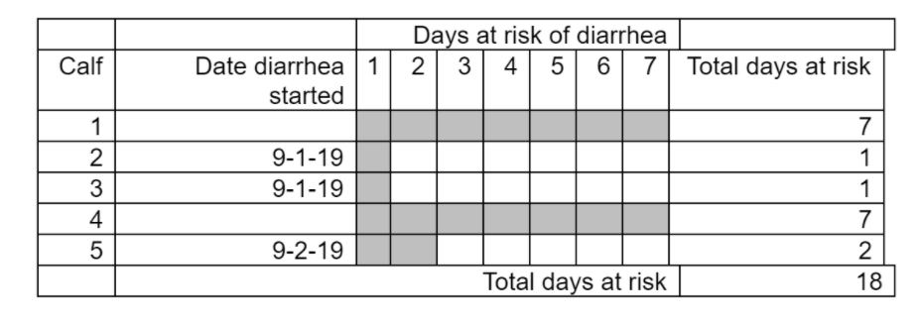
= 3 calves with diarrhea / 18 calf-days at risk of diarrhea = 0.17 calves / calf-day at risk
- Incidence rate is a ratio, not a proportion (numerator is not included in the denominator since the numerator is calves with diarrhea but the denominator is calf-days at risk, not calves).
So why measure the disease using incidence rates? Compare the situation to another situation, similar except the disease occurred later in the same week in the same calves.
A group of 5 calves with clinical signs of diarrhea from Sept 1-7 (total of 7 days).
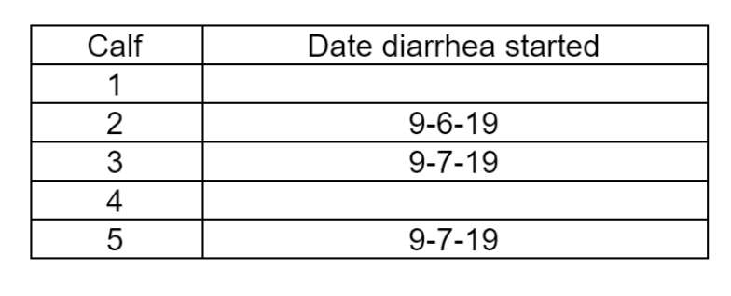
Case definition = Calf in this group with reported diarrhea during the first week of September 2019.
INCIDENCE RISK of diarrhea during the first week of September
= 3 calves with diarrhea / 5 calves at risk of diarrhea = 60%.
NOTE: The incidence risk is exactly the same as shown previously.
INCIDENCE RATE of diarrhea during the first week of September
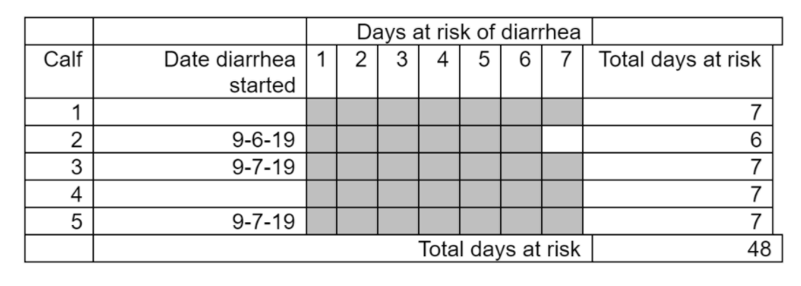
= 3 calves with diarrhea / 34 calf-days at risk of diarrhea = 0.09 calves with diarrhea / calf-day at risk
- The incidence rate is quite different from the previous situation (0.17 cases per calf-day at risk), because diarrhea occurred later in the week, and incidence rates take account of time in measurement.

